- Label the following diagram showing the amplitude, frequency and wavelength.
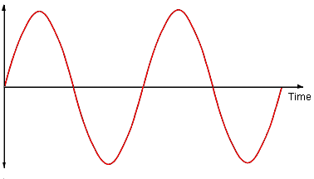
- Give the frequency. (Don’t forget the units!)
- What does the amplitude show?
- What does the frequency show?
- Complete the following examples.
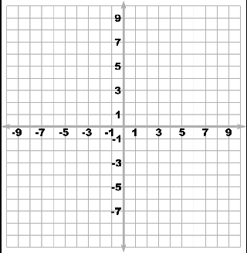
A loud, low pitched sound. | A soft, high pitched sound. | A loud, high pitched sound fading.
What is the frequency? | What is the frequency? | What is the frequency?

